Figure 4: Sequence of the cloned sagA gene

Figure 5: Sequence of recombinant SagA protein. The protein has a six Histidine tag at its N-terminus.

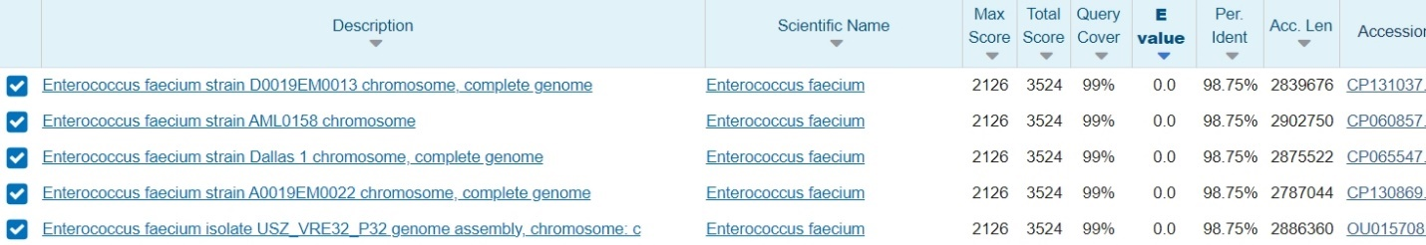
Figure 6: Results of sagA alignment against NCBI database (BLAST-N). The N-terminus His tag was excluded from the sequence used for alignment.

